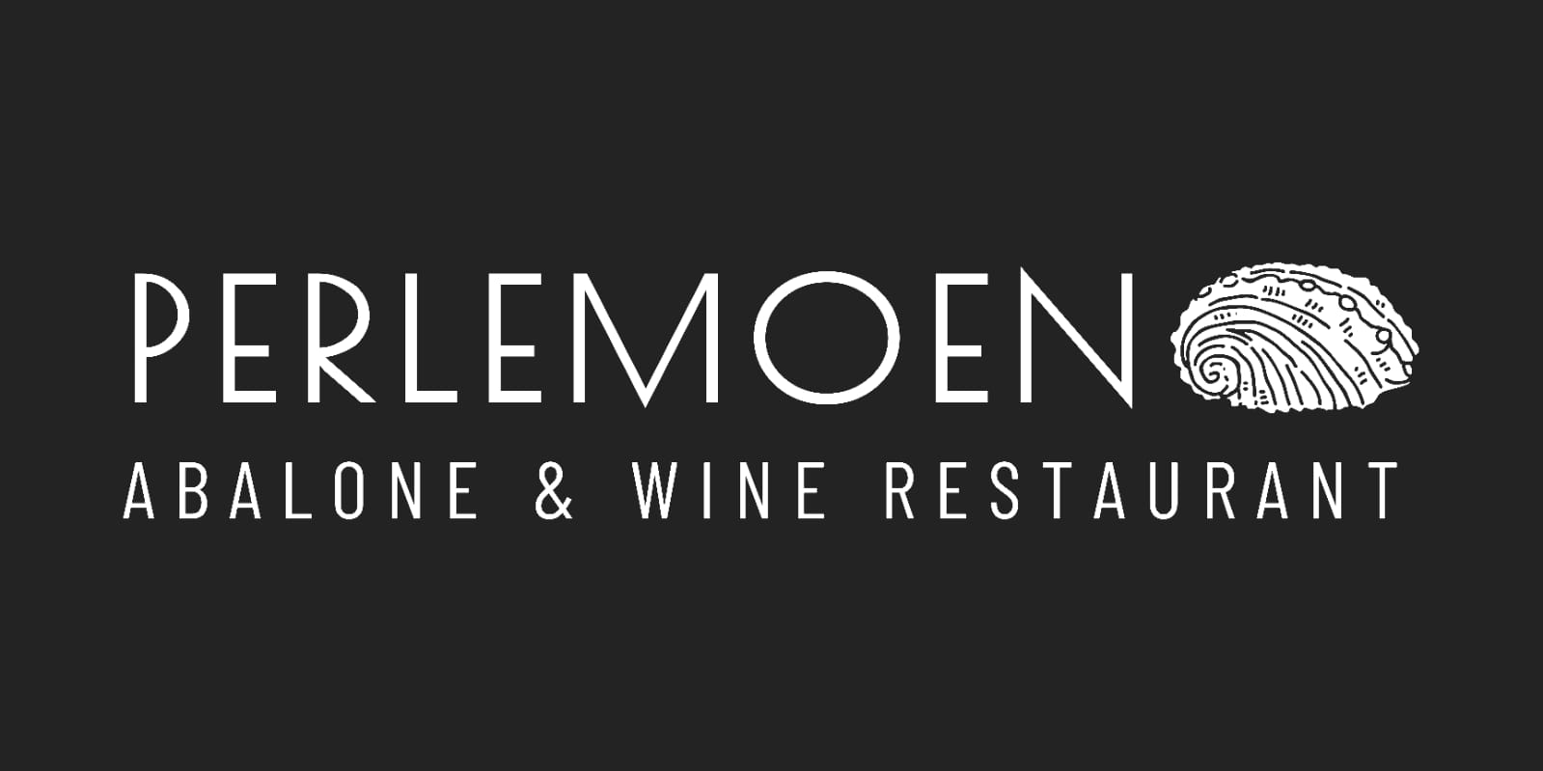

ABALONE & WINE RESTAURANT

Cocktails

Mimosa – Brut MCC and orange juice R70

Italian Job – Prosecco, Limoncello, basil and lime R89

Cosmopolitan – Vodka, Triple sec, lime and cranberry juice R70

Mojito – bacardi, Lime and fresh mint R80

Tequila Sunrise –tequila, orange juice and Grenadine R87

Aperol Spritz – Prosecco, aperol, soda and orange R79

Negroni - gin, vermouth and Campari R75

Pink Gin Cocktail – Fiddler’s Gin, Pink Tonic and Fresh Berries R85

Lady Hoy Gin Cocktail – Tanqueray Gin, Mint, Lime, Cucumber and Indian Tonic R85

Bloody Mary R85

(virgin versions of some cocktails available)

Beverages

Espresso Single R20 | Dbl R29

Macchiato | Cortado R32

Americano R30

Flat White R34

Cappuccino R35

Café latte R36

Chai latte R36

Decaf Cappuccino R35

Rooibos Cappuccino R36

Mocha R36

Hot Chocolate R36

Ceylon Tea/Rooibos R23

Eng breakfast/Green tea R25

Soft drinks

Coke/Coke zero/Fanta/cream soda R25

Appletiser / Red Grapetiser

R30

Soda / lemonade dry lemon

R22

Tonic R25

Juice R25

Tomato cocktail R30

Iced Tea| lemon or peach R27

Mountain Falls Still/Sparkling R30

Spirits/liqueurs

Absolut Vodka R25

Smirnoff R20

Bacardi Rum R25

Spiced Bacardi R20

Tanqueray Gin R25

Fiddler’s Gin R28

Gordon’s Gin R20

Bells R20

Jameson R35

Glenlivet Single Malt 12yrs R50

Olofberg Brandy R20

Grappa R40

Jagermeister R30

Campari R32

El Jimador Gold Tequila R32

Martini Rosso, Vermouth R20

Limoncello R30

Kahlua R28

Amarula R20

Frangelico R20

Contreau R38

Beers/ciders

Old harbour Lager R50

Black label R30

Castle Light R30

Folk & Goode IPA R50

Savannah Dry R35

Hunters dry R35

Brutal Fruit R35

Heineken non alc R35

Savannah Lemon – Non Alc R35



ABALONE & WINE RESTAURANT

Method Cap Classique | Bubbles

Benguela Cove, Cuvee 58 R285 Bottle | R75 per glass

Benguela Cove, Cuvee 58 Rosé R285

Creation Elation R510

White Wine

Sauvignon Blanc

Ataraxia R230

Per glass R60

Southern Right R260

Benguela Cove:

Lighthouse R180

Estate Sauvignon R275

Chardonnay

Bouchard Finlayson

Sans Barrique R295

Kaaimansgat R360

La Vierge , Redemption R200

Hamilton russel estate R895

Blends

Bouchard Finlayson

Blanc de mer R175

Whale haven Abalone R165

Per glass R50

Ashbourne, Sandstone R470

Chenin Blanc

Gabrielskloof R220

Per Glass R60

Creation, Cool Climate R300

Viognier

Creation R245

RosÉ

Gabrielskloof Rosebud R185

per glass R55

Creation Rosé R230

Red wine

Pinot Noir

Ataraxia R535

Bouchard Finlayson

Galpin Peak R665

Hamilton Russel Estate R985

Shiraz

Creation Reserve Syrah R580

Gabrielskloof Syrah. R296

Pinotage

Whalehaven R325

Southern Right R575

Blends

La Vierge, Nyphomane R290

Whale haven Abalone R165

Per Glass R50

Dessert Wine

Creation Fine Cape Vintage Port R50